Brand Name : ELNINO RESTAURANT

Category : Food restaurant

Target Audience: All (Men , Women and Kids )

Email : [restaurantelnino@gmail.com](mailto:restaurantelnino@gmail.com)

Logo theme : simple, modern, and sophisticated

Elnino restaurant logo

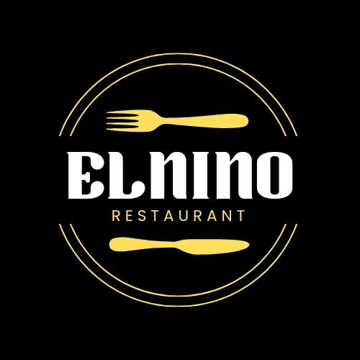

Restaurant Face book Account Link :

<https://www.facebook.com/elnino.restaurant.2023?mibextid=ZbWKwL>

Blog :

<https://elninorestaurantfoodie.blogspot.com>